**Hands On Lab 1**

# Create a New Build Job in Jenkins Freestyle Project

## **What is a Jenkins Freestyle Project?**

****Jenkins Freestyle Project**** is a repeatable build job, script, or pipeline that contains steps and post-build actions. It is an job or task that can span multiple operations. It allows you to configure build triggers and offers project-based security for your Jenkins project. It also offers plugins to help you build steps and post-build actions.

The types of actions you can perform in a Jenkins build step or post-build action are quite limited. There are many standard plugins available within a Jenkins Freestyle Project to help you overcome this problem.

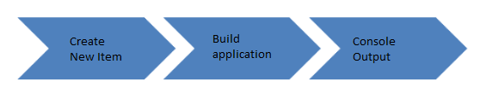

How to Create a Job in Jenkins

## **How to Create a New Build Job in Jenkins**

The freestyle build job is a highly flexible and easy-to-use option. You can use it for any type of project; it is easy to set up, and many of its options appear in other build jobs. Below is a step by step process to create job in Jenkin.s.

****Step 1) Login to Jenkins****

To create a Jenkins freestyle job, log on to your Jenkins dashboard by visiting your Jenkins installation path. Usually, it will be hosted on localhost at http://localhost:8080 If you have installed Jenkins in another path, use the appropriate URL to access your dashboard as shown in the below Jenkins job creation example.

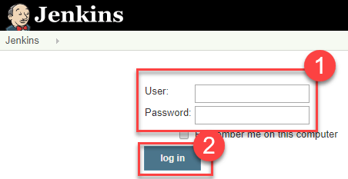

****Step 2) Create New Item****

Click on “****New Item****” at the top left-hand side of your dashboard.

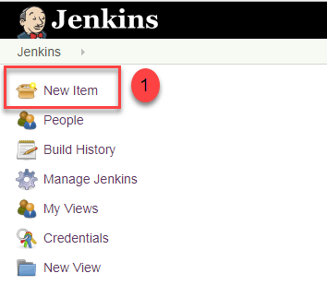

****Step 3) Enter Item details****

In the next screen,

1. Enter the name of the item you want to create. We shall use the “Hello world” for this demo.
2. Select Freestyle project
3. Click Okay

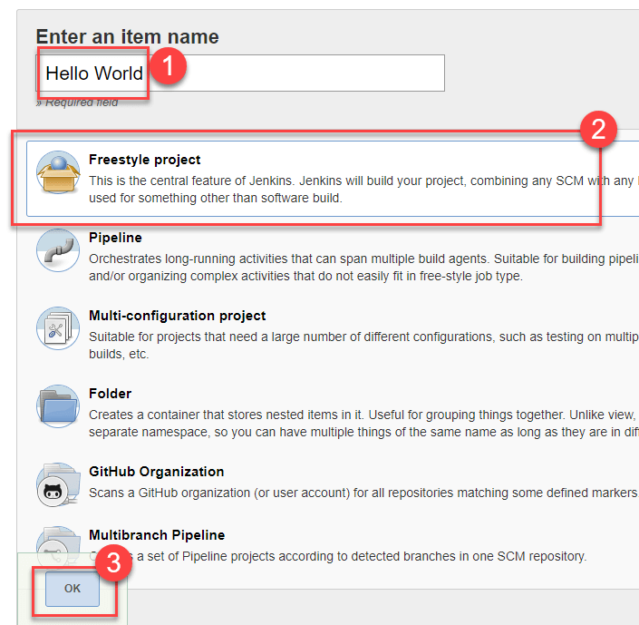

****Step 4) Enter Project details****

Enter the details of the project you want to test.

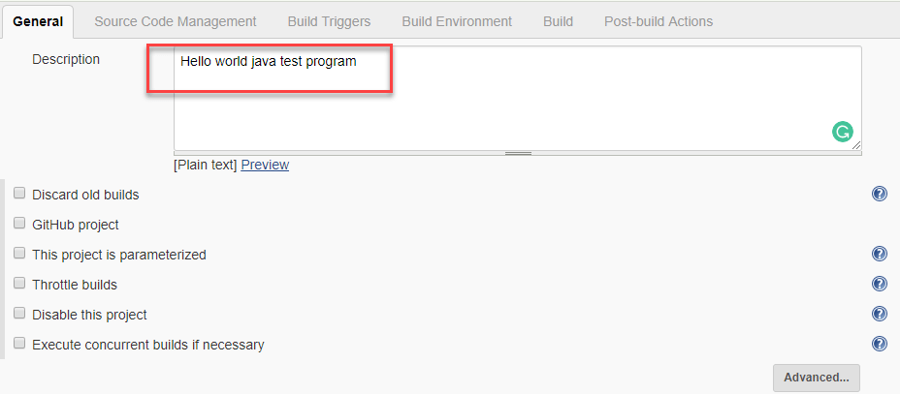

****Step 5) Enter repository URL****

* ****Create a New Java Class called HelloWorld.Java.****
* ****Create a New Repository in your GitHub account.****
* ****Push HelloWorld.java to the new repository.****

Under Source Code Management, Enter your repository URL.

It is also possible for you to use a local repository.

If your GitHub repository is private, Jenkins will first validate your login credentials with GitHub and only then pull the source code from your GitHub repository.

****Step 6) Tweak the settings****

Now that you have provided all the details, it’s time to build the code. Tweak the settings under the ****build**** section to build the code at the time you want. You can even schedule the build to happen periodically, at set times.

Under ****build****,

1. Click on “****Add build step****”

2. Click on “****Execute Windows batch command****” and add the commands you want to execute during the build process.

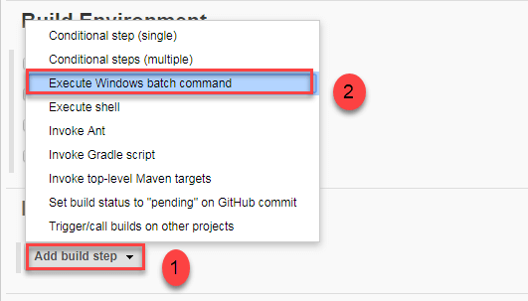

Here, we have added the java commands to compile the java code.

We have added the following windows commands:

javac HelloWorld.java

java HelloWorld

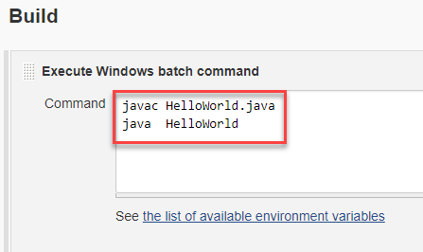

****Step 7) Save the project****

When you have entered all the data,

1. Click ****Apply****
2. ****Save****the project.

****Step 8) Build Source code****

Now, in the main screen, Click the ****Build Now****button on the left-hand side to build the source code.

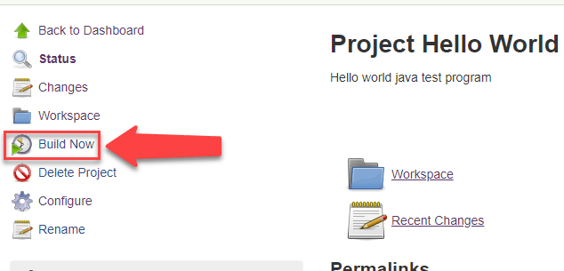

****Step 9) Check the status****

After clicking on ****Build now,****you can see the status of the build you run under ****Build History****.

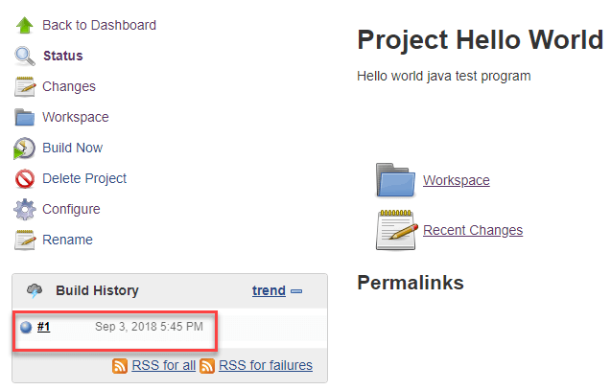

****Step 10) See the console output****

Click on the ****build number****andthenClick on ****console output****to see the status of the build you run. It should show you a success message, provided you have followed the setup properly.

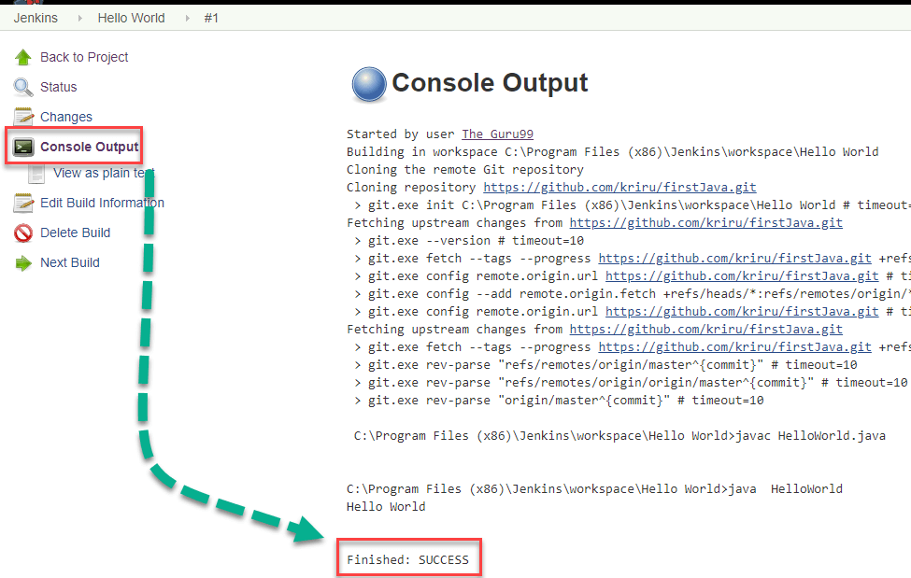

In sum, we have executed a HelloWorld program hosted on GitHub. Jenkin pulls the code from the remote repository and builds continuously at a frequency you define.

## **Summary**

* Jenkins Freestyle Project is a repeatable build job, script, or pipeline that contains steps and post-build actions. It is an improved job or task that can span multiple operations.
* The types of actions you can perform in a build step or post-build action are quite limited. There are many standard plugins available within a Jenkins Freestyle Project to help you overcome this problem.
* Freestyle build Jenkins jobs are highly flexible and easy-to-use. You can use it for any type of project; it is easy to set up, and many of its options appear in other build Jenkins jobs.
* If your GitHub repository is private, Jenkins will first validate your login credentials with GitHub and only then pull the source code from your GitHub repository.

***************************************************************************************************